**Celebrating women entrepreneurs**

Mar 15 2015 : The Times of India (Delhi)

It was all about success stories when Vandy Mehra, director, Study ByJanak, organized an evening dedicated to women achievers in the city. Nine panelists from different walks of life shared their experiences though various interaction sessions, including a fun question-and-answer round with the achievers.

Mili Bhandari from The Hiatus was the venue partner for the evening, while RatnaVerma provided delicious cakes for the ladies. ShabnamSinghal, ShaziaIlmi, Bubbles Sabharwal, Angel Mehra and Preeti Ghai were some of the others who were in attendance.

[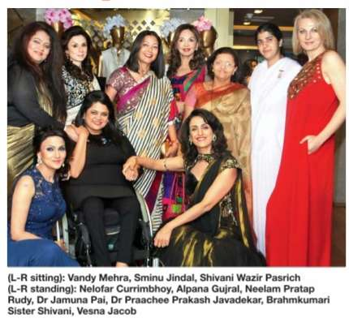](http://epaperbeta.timesofindia.com/Article.aspx?eid=31808&articlexml=Celebrating-women-entrepreneurs-15032015105008)

<http://epaperbeta.timesofindia.com//Article.aspx?eid=31808&articlexml=Celebrating-women-entrepreneurs-15032015105008>

