Siddhartha Lal | The Bulletproof man
Siddhartha Lal | The Bulletproof man
Priya Ramani
Share
First Published: Fri, Sep 10 2010. 10 14 PM IST
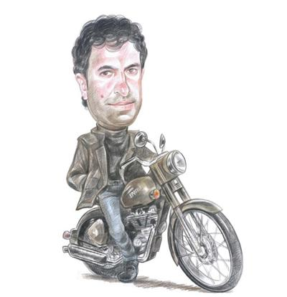
Easy rider: Lal says the Enfield has been successfully repositioned as a cool urban bike.
Updated: Fri, Sep 10 2010. 10 14 PM IST
What’s not to like about Siddhartha Lal? He and his wife Natasha do the Lounge couple’s tussle every Saturday (me first, no me first—the woman always wins); he is the man responsible for the miraculous rescue of the iconic Royal Enfield motorcycle in this past decade; and, oddly enough for someone who works in the automobile sector, he worries about pedestrians and believes that “walkability is the killer app of urban mobility”.
Even before we meet for lunch at Latitude 28°, the trendy restaurant that sits above his mother’s iconic Good Earth design store in Delhi’s Khan Market, an enterprising colleague has informed me that he is working on “sustainable urban mobility”. Sure enough, he brings up walkability 10 minutes after we meet.
Easy rider: Lal says the Enfield has been successfully repositioned as a cool urban bike.
For a while now, Lal, the 37-year-old head of the Eicher group, has been working his head around the problem of urban mobility. By the year 2050, he says, our cities could hold nearly a billion people, and the problems surrounding our already creaking urban infrastructure will only get messier. More highways are not the answer, says Lal, who believes in sustainable solutions.
So he brainstorms with all kinds of kindred spirits, from IIT professors Dinesh Mohan and Geetam Tewari and differently abled activist Sminu Jindal to Danish bicycle designer Jens Martin Skibsted and the MIT professor and co-founder of car-sharing service Zipcar, Robin Chase. He’s on the World Economic Forum’s global agenda council for transportation and there are plenty of opportunities to meet mayors from all over the world. If I let him, he would spend the entire lunch talking about how other cities have tackled their urban transport problems.
In 2003, for instance, Seoul broke down a busy highway that ran through the centre of town and reopened access to a nullah (stream) around which the city built a big urban park. The Cheonggyecheon Restoration Project created a vibrant public space in the heart of that city.
“I don’t know where the interest and the business collide but eventually we’re an automotive company and we have interests in these areas. Our business is clearly in mobility, it’s not in making a vehicle,” he says. For now, he’s happy to become an expert on the subject.
“I feel like an Italian mafia don sitting here,” he says as the staff scurries to do his bidding. I resist the temptation to point out that with his curly dark hair and the mole on his right cheek, he could easily pass off as a good-looking European gangster.
It’s only recently that Lal is relaxed enough to meet for leisurely lunches with people such as myself. The past few years have been a blur of 12-hour “full immersion” work days, structuring and getting a joint venture with Swedish truck-maker Volvo off the ground. Volvo partnered with group flagship Eicher Motors and invested Rs 1,082 crore for a 50% stake in the new company VECV (Volvo Eicher Commercial Vehicles) in December 2007. Lal’s job was made tougher because the economy slowed just after the two firms signed on the dotted line, but this year sales are back on track.
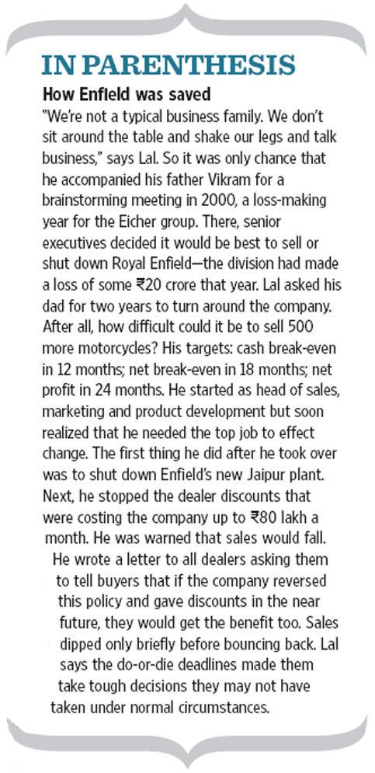
In June, the company announced it would spend Rs 288 crore to set up a new engine-making facility, making India Volvo’s global manufacturing hub for these particular engines. “We’re very well placed now to meet our future needs and targets so I’ve taken a step back as far as the joint venture is concerned,” says Lal.
I can barely tell my driveline from my chassis so I’m relieved when Lal says that since July he no longer spends 90% of his time on this partnership. While he’s still managing director of VECV and spends about half his time tracking the big picture in the heavy vehicles business, he’s handed over the operational reins to new CEO Vinod Aggarwal. And, among other things, Lal has gone back to being more involved with Royal Enfield.
He’s also working on hiring a new corporate team for Eicher Motors, finding ways to deploy the surplus cash on his company’s balance sheet and becoming an expert on sustainable urban mobility. Recently, he convinced Siam (Society of Indian Automobile Manufacturers) to hold a session on the subject at their annual conference.
Last month he went on a testosterone-fuelled, Enfields-only motorcycle trip from Manali to Ladakh with six friends. It’s a trip he’s wanted to do for 15 years though it ended up being a bigger adventure than he had bargained for when the group got caught in the Leh floods and had to be air-lifted back.
“Personally I feel like I’m in a brilliant space,” he says. “The business is going well, I’ve got time. I can be more creative and entrepreneurial, the tension is easing and my life is opening out more.”
Lal’s been on a rollercoaster since 2000 when, as corporate legend has it, he prevented his father from selling Royal Enfield. I ask him if he really raised his hand in a board meeting and announced he could save the loss-making motorcycle company. “I didn’t raise my hand the way you are right now, but that’s pretty much how it happened,” he laughs. “I was so naïve, and I’m happy I was. If I hadn’t been so naïve it would have been horrible. I would never have taken up the challenge,” he says (see box, How Enfield was saved).
At Enfield, where Lal is just finding his new rhythm, the business model is finally working after more than a decade-long struggle. In the past few years the brand has been successfully repositioned as a cool urban bike though a third of Enfields are still sold in Punjab, Haryana and Delhi. “If our all-India market share is 0.5%, our Sardar market share is 10-15%,” he says.
Thanks to its new-found popularity, the waiting time for an Enfield can now stretch up to nine months and the company recently announced it would invest Rs 200 crore to double capacity in the next two years. Since it addressed the safety concerns of its consumers (for example, traditionally brakes were always located on the “wrong” side; starting it once required incredible patience), Lal says, there’s been an explosion in the number of 18- to 21-year-old Enfield buyers. Café Racer, the next new model, is due at the end of 2012 and new launches will follow every two-three years.
“The really long-term master plan is to take Royal Enfield to a very different space. Our brand must be intricately woven in with long rides. When someone buys this bike it should be because he thinks he can drive it to the Himalayas,” says Lal. He also plans to look at areas such as after-market service, spare parts, customization, accessories (though Enfield has tried the last before and failed), and exports to developing markets. “It’s counterintuitive but developed countries were buying us earlier because of the vintage factor. Now that our products are much better in terms of reliability, we can sell to developing markets,” he says. The company recently launched its motorcycles in Colombia and will also export to other countries in South America, Africa and South-East Asia. “At Rs 500 crore revenue, it’s not a huge brand, but it’s got this whole aura which we’re trying to build on,” he says.
priya.r@livemint.com

