India wins the bid for hosting the next TRANSED in 2012

Svayam has been awarded the bid to host TRANSED 2012 in India. Ministry of Transport, Government of National Capital Territory of Delhi and Ministry of Tourism, Government of India had extended their support right from the bidding stage and shall be co-hosts for TRANSED 2012.
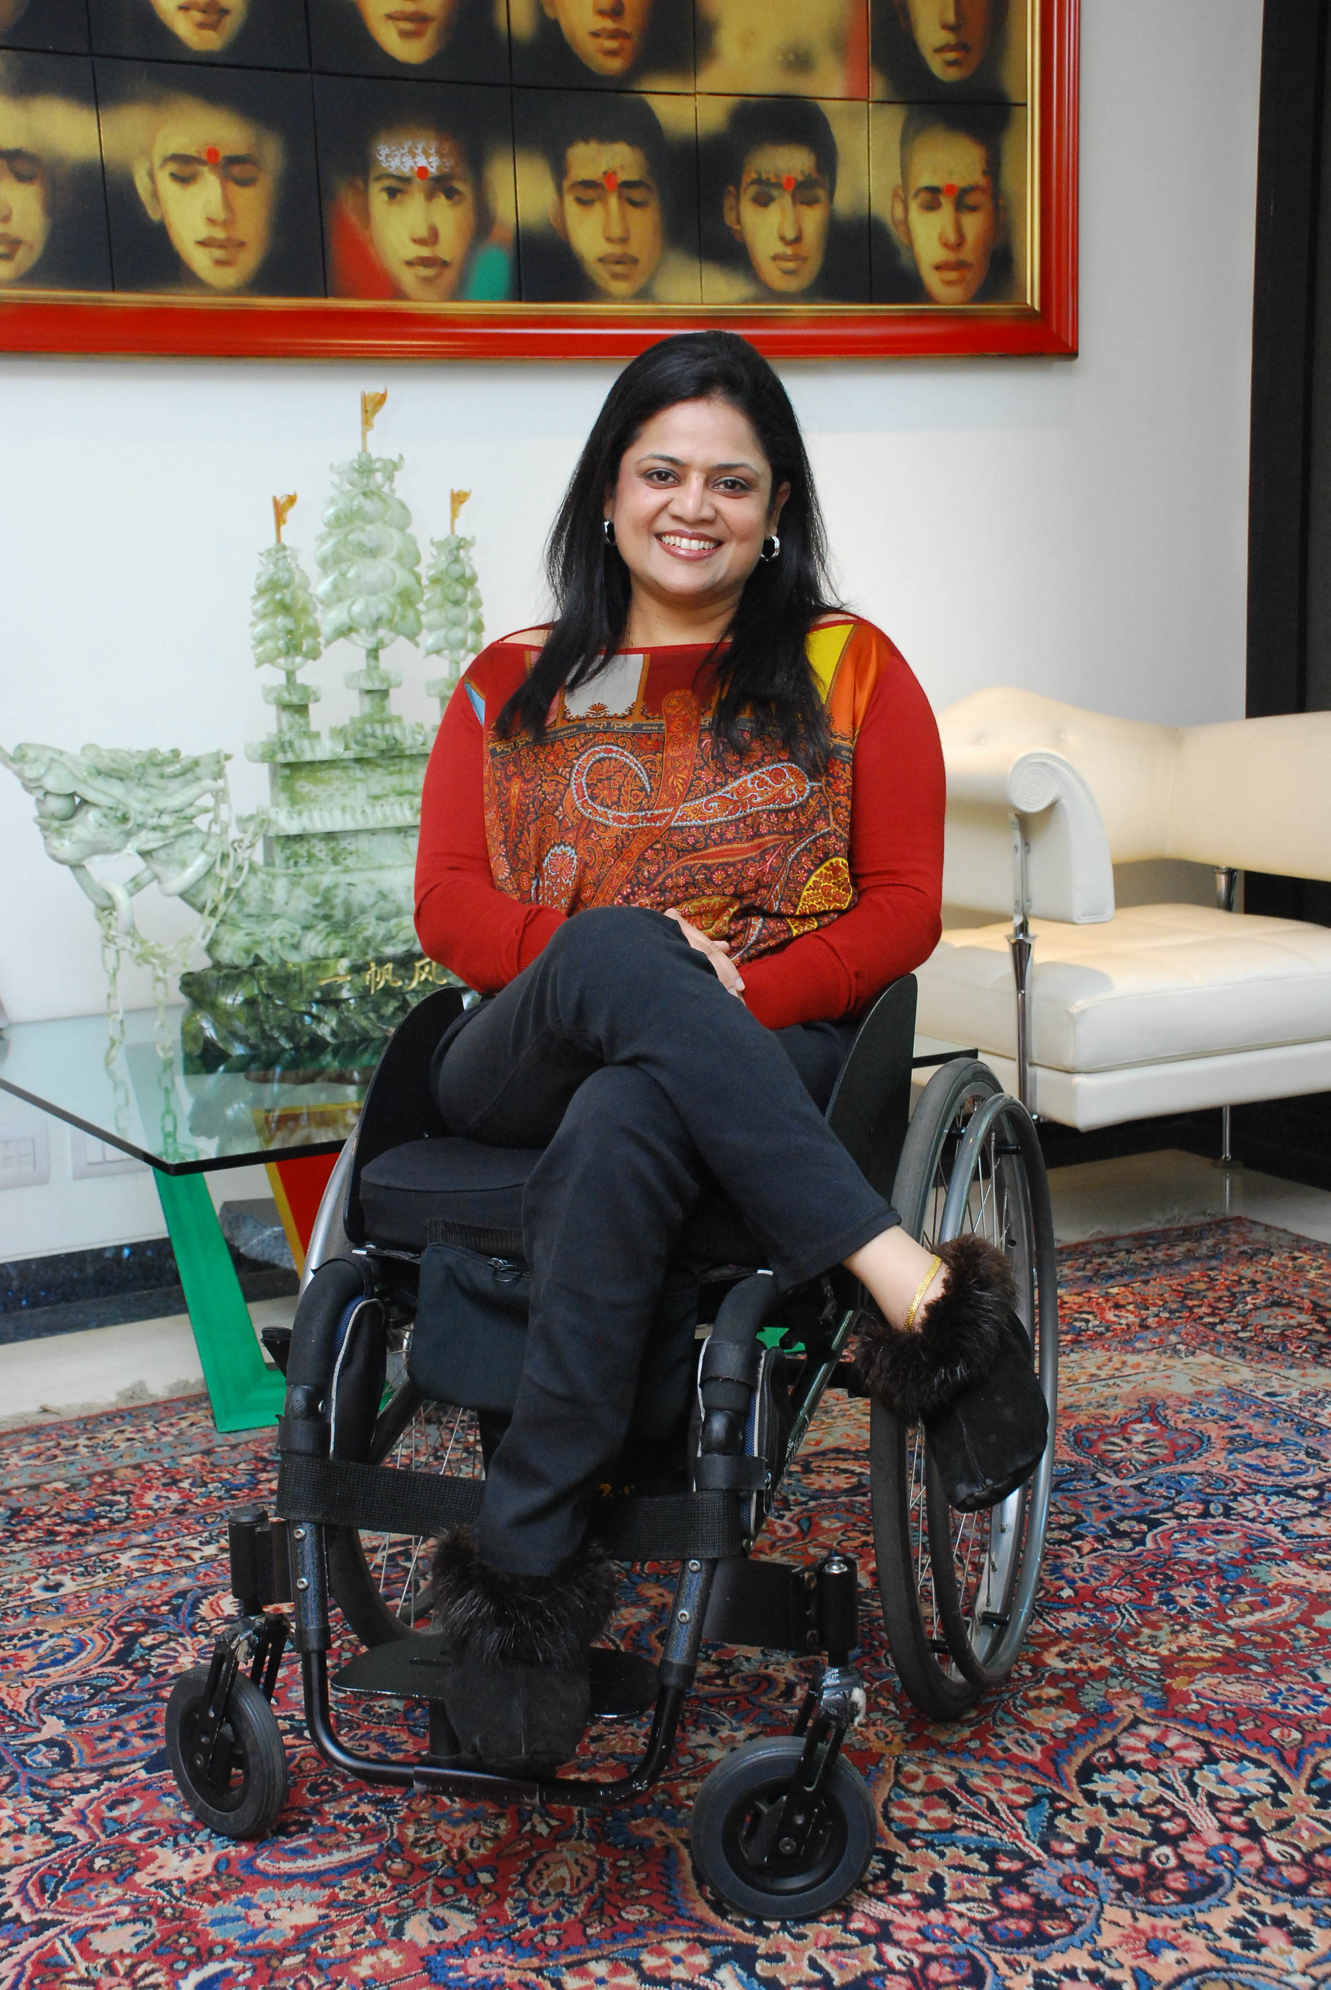
“It is a matter of pride and deep personal satisfaction that Svayam has been instrumental in bringing TRANSED 2012 to India. I am confident that this would open up avenues of not only making India accessible but will be a step closer to taking the civilization as a whole to a new world order where manmade built environment is inclusive and enabling”
-Sminu Jindal, Founder of Svayam

From the outset, the TRANSED series of conferences have been held primarily to serve the needs of transport professionals; including researchers, policy makers, planners, administrators and operators. The main objectives of the conference remains the exchange and dissemination of knowledge and experience for the development of transport services and systems that meet the needs of people who have mobility impairments. We are confident that by holding it in Delhi, this tradition will get further impetus and provide mutual knowledge sharing between advanced nations and developing countries alike.
India and the Indian subcontinent stand to gain a lot from TRANSED 2012.

- An estimated 100 million people (disabled and seniors) in need of accessible transportation from Afghanistan, Pakistan, to Nepal, Bangladesh, India and Sri Lanka

- There are a large number of people living in this part of the world who are disabled, due to disease, old age, war, civil conflicts and acts of terrorism (now commonplace across the globe)

- Despite PWD Act being passed in 1995, the implementation has a long way to go.

- India was one of the first countries to ratify the UN Convention on The Rights of Persons With Disabilities (UNCRPD)

- The Prime Minister of India directed that the PWD Act be revisited to align it with the mandates of the UNCRPD

- A recent World Bank report has estimated the disabled population to be between 4% to 8% (40 to 80 million). Added to this are 90 million seniors.

- The impact of accessible transport systems and infrastructure will enhance the opportunity for 130-170 million people in India alone.

- Delhi as the site for TRANSED 2012 would act as message board to the Indian subcontinent on ways to remove barriers to accessibility.

- Accessible transportation systems (BRTS and Metro Rail) are being implemented in the major cities of the country, but only meet a small portion of the daily travel demand.

- Delhi Government is using CNG for all public transport vehicles and government fleets to reduce carbon foot print (largest fleet using CNG in the World).

- Sustainable transportation, reducing carbon foot prints and climate change, all point towards the need for expansion of effective accessible public transport systems.

- Since India has ratified the UNCRPD, hosting TRANSED 2012 will help to focus on implementation strategies integrated nationwide to meet the mandate.

- It will provide a chance to integrate Inclusiveness through accessibility.

