Success & Ability – SlideShare

Ability Magazine, October 2008

INCLUSIVE TOURISM
            - The Way to Go!




                                 A
                                    ...30             to receive this welcome trend? One must bear in mind however, that tourism is not confined to
             ...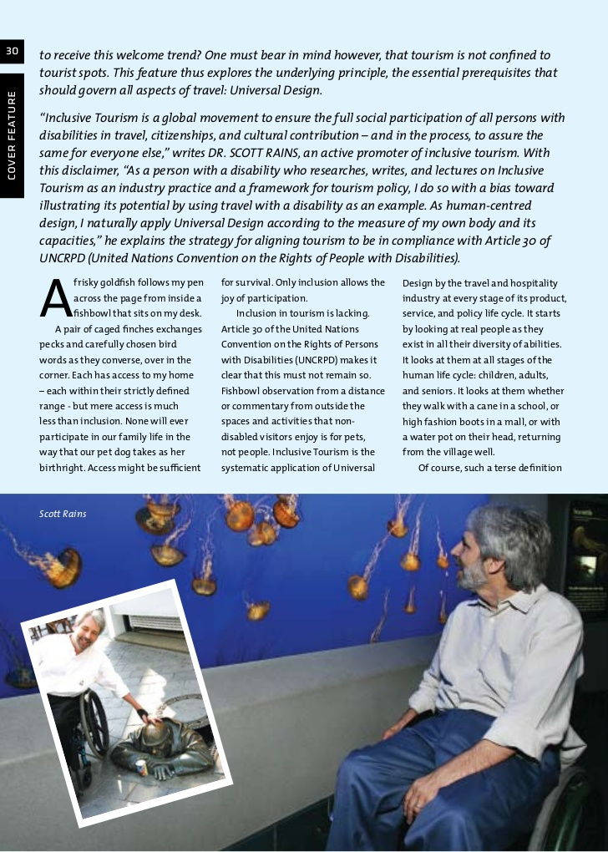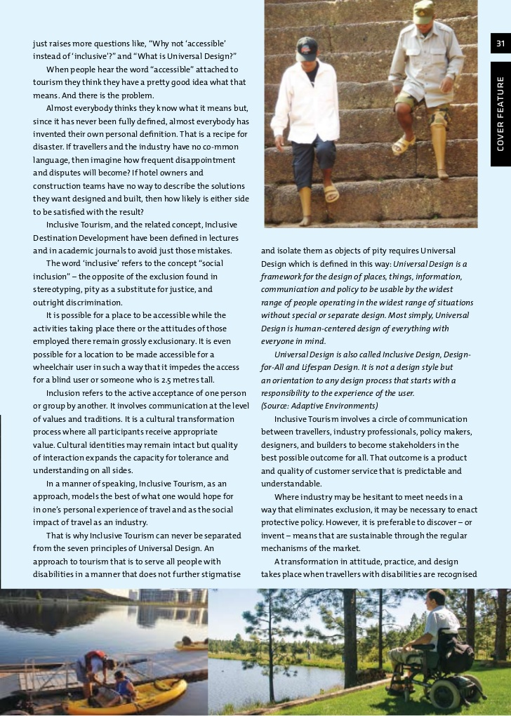INCLUSIVE TOURISM
                                                      - The India Connection


T
      he demand for inc...listings of places of interest in Delhi and NCR      Survey of India (ASI) had issued an
like budget and star hotels, shop...persons with disabilities. Travelling with dignity is an
individual’s right.



A    ccessible tourism is an ongoing endea...appreciated by the trade across the world.                     they could incorporate features that enhance accessibility
...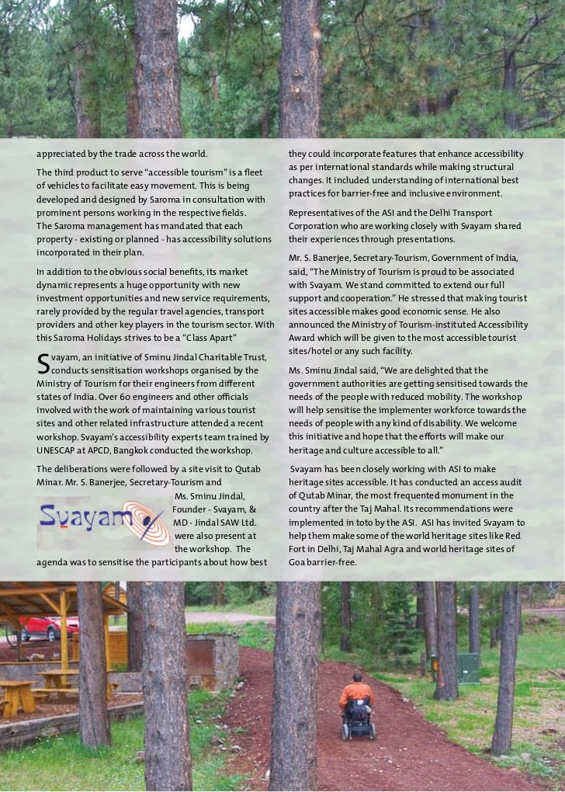

<https://www.slideshare.net/srains/success-ability>