Sheila for making Delhi disabled-friendly
STAFF REPORTER The Hindu,NEW DELHI:, SEPTEMBER 19, 2012 00:00 IST
UPDATED: SEPTEMBER 19, 2012 04:55 IST
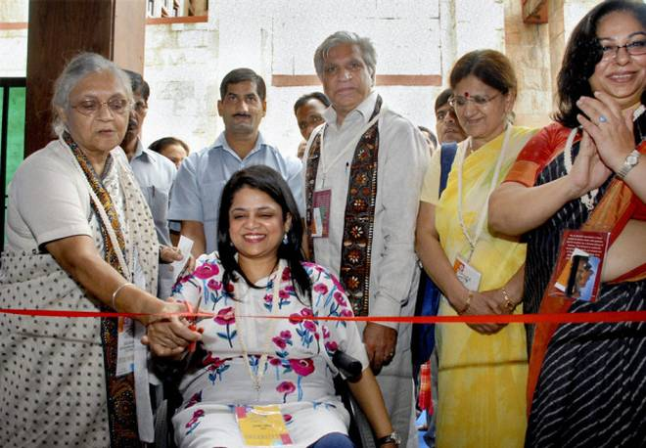
Meeting new challenges:Chief Minister Sheila Dikshit inaugurating the 13th International Conference on Mobility and Transport for the Elderly and Disabled in New Delhi on Tuesday.- Photo: PTI
The Delhi Government is keen to expand and upgrade the bus rapid transit corridor and will ensure that these corridors are more comfortable and accessible for the disabled, said Chief Minister Sheila Dikshit on Tuesday.
Ms. Dikshit said her government is aspiring to make Delhi a “caring city” for the elderly and the disabled in particular. The Chief Minister was speaking at the inaugural session of the four-day long, 13{+t}{+h}International Conference on Mobility and Transport for Elderly and Disabled.
Creating awareness
Referring to the collaborative efforts made by the Delhi Government and Transed to make the city disabled-friendly, Ms. Dikshit said: “We have worked together to make places like Qutub Minar, Red Fort, bus queue shelters, public conveniences accessible.” She said efforts to help raise awareness and sensitise people to the cause of accessible and inclusive environment will continue.
Citing examples of how the city government had made efforts to improve accessibility for the disabled, Ms. Dikshit said, the Delhi Metro has taken care for the special requirements of the disabled persons. “In our offices washrooms have been made for people with special needs. As per city government directions all new government buildings will be constructed with disabled and elderly friendly features,” she said.
The TRANSED conference is designed to review advances in research, profile international breakthroughs and explore perspectives for technological innovations in response to the mobility challenges of an ageing population and persons with disabilities.
It also aims to examine ways to address challenges associated with improving mobility and transportation needs for the elderly and disabled.
Delhi Transport Minister Ramakant Goswami said the Transport Department has been instructed to ensure barrier-free accessibility for the disabled and elderly people. He pointed out Delhi with a population of over 1.70 crore has a large percentage of elderly persons apart from the differently-abled.
The Transport Department has made elaborate arrangements to convert all bus queue shelters as disabled friendly, he said, adding that efforts are on for installation of signages for the elderly and disabled persons.
The conference is being organised by NGO Svayam in association with the Delhi Government, Union Ministry of Urban Development, Union Ministry of Tourism, Canadian Transportation Agency and Transportation Research Board, USA.
http://www.thehindu.com/todays-paper/tp-national/tp-newdelhi/sheila-for-making-delhi-disabledfriendly/article3913364.ece

